2024-2025 CYF calendar

The dates listed below are important dates for the upcoming school year, including holiday breaks and grade-leveled Milestone (Together in Faith) Events. While we stick to the calendar as much as possible, all dates are subject to change because of unforeseen circumstances, so watch for more details!

**September 2024**

4—Confirmation Kick Off

8—Ebeneezer Sunday

11—Bedtime Bible stories;

SS teacher meeting

15—First Day of SS

22—3rd grade read Bibles in worship

29-

**October**

6—5th-6th grade Playing with

Fire (7th grade too?)

13—

16—No Confirmation MEA

20—Intergenerational Service

Sunday LWR kits & more

27—SS program part sign up

November

3—Christmsas program Kickoff

Daylight Saving’s Time Ends

10—SS practice

17—SS practice

24—SS practice

December

1—Christmas practice

Advent begins

Christmas in the barn?

8—Christmas practice

15—Final dress rehearsal

Christmas program 10:30 am

(back up date Dec 20 7 pm)

18--Last Confirmation of year

22—No SS

31—No SS

**January 2025**

5—Sunday school resumes

8—Confirmation resumes

12--Beach Party for

Infants, toddlers & parents

19— Intergenerational Care Packages

26—Annual meeting

**February**

2—

9—1st grade God & Gifts

Kind Lord’s Prayer

16—2nd-3rd grade It’s Not Fair

23—

**March**

2—4th Grade Creed

5 Ash Wed

9—

16— Preschool Pray &

Play

23—

30—

**April**

6 — 5th-6th grade worship

13— Palm Sunday breakfast & egg hunt

17-- Maundy Thursday

1st communion

20—Easter No S

27—

**May**

4—Confirmation at 11:00

11—Last day of SS;

Group SS Bring animals?

18—Baccalaureate

June Scuba/Zoorific Vacation Bible School

5:20 pm Meal

6-7:30 pm VBS

**June**

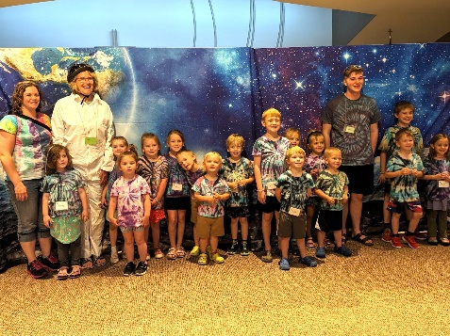

**First Communion Training**

April 6 at 2 pm (Sun)

April 7 at 3:30 pm (Mon)