2023-24 Milestone Ministry: nurturing your child’s faith one step at a time

Throughout the school year, GS provides an opportunity for students and their adults to celebrate important steps in their faith journey. Together you have the opportunity to attend an age-specific event, providing you with a wonderful opportunity to deepen your child’s faith (and yours) one step at a time, milestone by milestone. We call this together in faith & milestones ministry. Most TIF Events will be held on Sunday mornings.
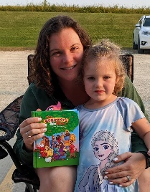
Wednesday, September 13 at 6 pm—3 year old Bedtime Bible Stories
A special time for kids and parents to prepare for starting Sunday school. A time to meet your teacher. Receive your own Bible. Explore the church before the first day of Sunday school on September 18.
Sundays September 24 & October 1 —2nd-3rd Grade Bibles
You’ll receive your Bible during the 9 am worship service on Sept 25. We’ll have fun getting to know our Bible and how to use them on Sept 24 * Oct 1 at 10 am during the education hour.

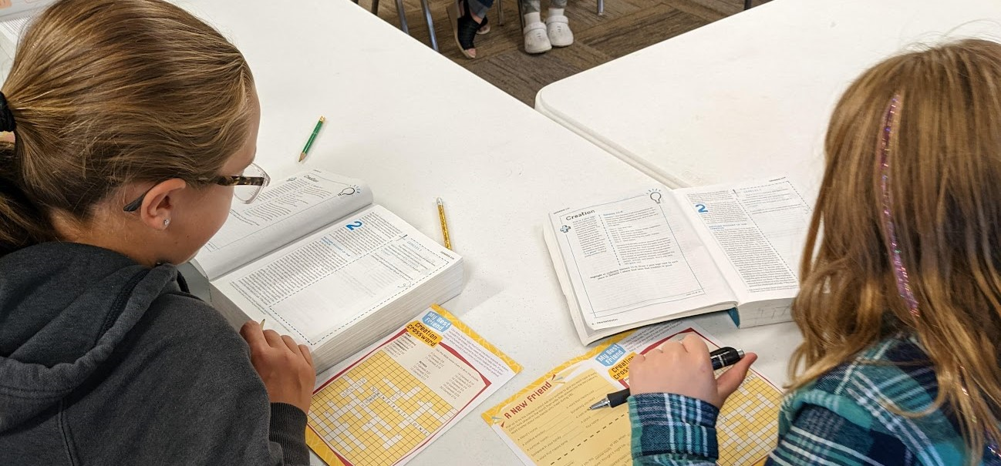

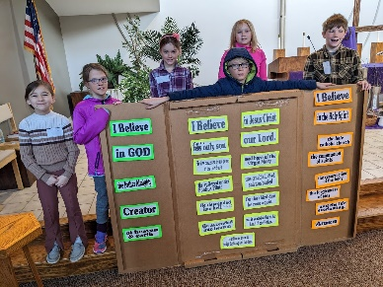
Sunday October 8
Playing with Fire 5th-6th grade
Be worship leaders and practice acolyte skills at 10 am.
Sunday, January 7—Beach Party for babies and toddlers
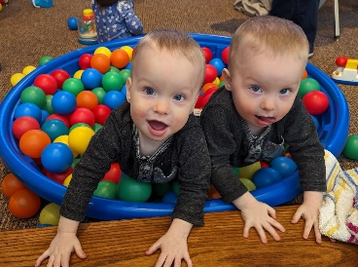
Remember your baptism as you pray and play together at wororship & 10am.

Sunday, February 11—1st grade God & Gifts
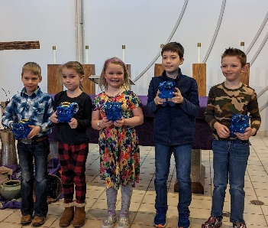
Talk about offering-where it comes from and where it goes at 10 am.

Sunday, February 11 Kindergarten Lord’s Prayer Event
Parents are invited to join their kids during the 10am Sunday School hour to celebrate the Lord’s Prayer in fun and different ways to pray & prepare to lead it in worship.
Sunday, March 3—4th Grade Creed Event
What do we believe? Learn the parts of the creed and what it means. Then lead it in worship.

Sunday, March 3 for 5-6th grade Worship
SWhy do we worship? What are the parts of the service? Everything you want to know about worship.

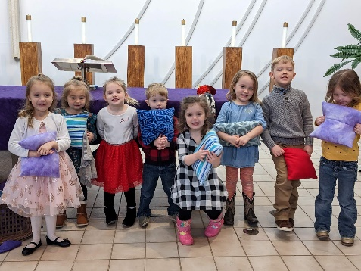
Sunday, March 17— Preschool Pray and Play for 3 & 4 year olds
We’re never too young to learn how to pray. Join us at 10 am as we explore prayer and take home some fun new ways to pray and play together!
Holy Communion Preparation for 2nd Grade & Up: Sun, March 17 at 2 pm OR Mon, March 18 at 3:30 pm Learn about the sacrament of Holy Communion. All are Welcome at God’s Table. In preparation for first communion on Thursday, March 28.
