2023-2024 CYF calendar
The dates listed below are important dates for the upcoming school year, including holiday breaks and grade-leveled Milestone (Together in Faith) Events. While we stick to the calendar as much as possible, all dates are subject to change because of unforeseen circumstances, so watch for more details!
September 2023
6—Confirmation Kick Off
13—Bedtime Bible stories;
SS teacher meeting
17—First Day of SS
24—2nd-3rd grade Bibles

October

1— 2nd-3rd grade Bible skills
8—5th-6th grade Playing with
Fire
15—
18—No Confirmation MEA
22—Intergenerational Service
Sunday LWR kits & more
29—SS program part sign up

November

5—Christmsas program Kickoff
Daylight Saving’s Time Ends
12—SS practice
19—SS practice
26—SS practice

December

3—Christmas practice
Advent begins
10—Christmas practice
17—Final dress rehearsal
Christmas program 10:30 am
(back up date Dec 20 7 pm)
20—Last Confirmation of year
24—No SS
31—No SS

January 2023

3—Confirmation resumes
7—Baptism Beach Party for
Infants, toddlers & parents
14—
21— Intergenerational Care Packages
28—Annual meeting

February

4—
11—1st grade God & Gifts
Kind Lord’s Prayer
14—Ash Wed Lent Begins
18—
25—

March

3—4th Grade Creed
5th-6th grade worship
10--
17— Preschool 1 & 2 Pray &
Play
24—Palm Sunday breakfast & egg hunt
28- Maundy Thursday
1st communion
31—Easter Sunday No SS

April

7 —
14—
21—
28—

May
5—Confirmation at 11:00
12—Last day of SS;
Group SS activity?
21—Baccalaureate

June

June 3-5 Stellar Vacation Bible School
5:20 pm Meal
6-7:30 pm VBS

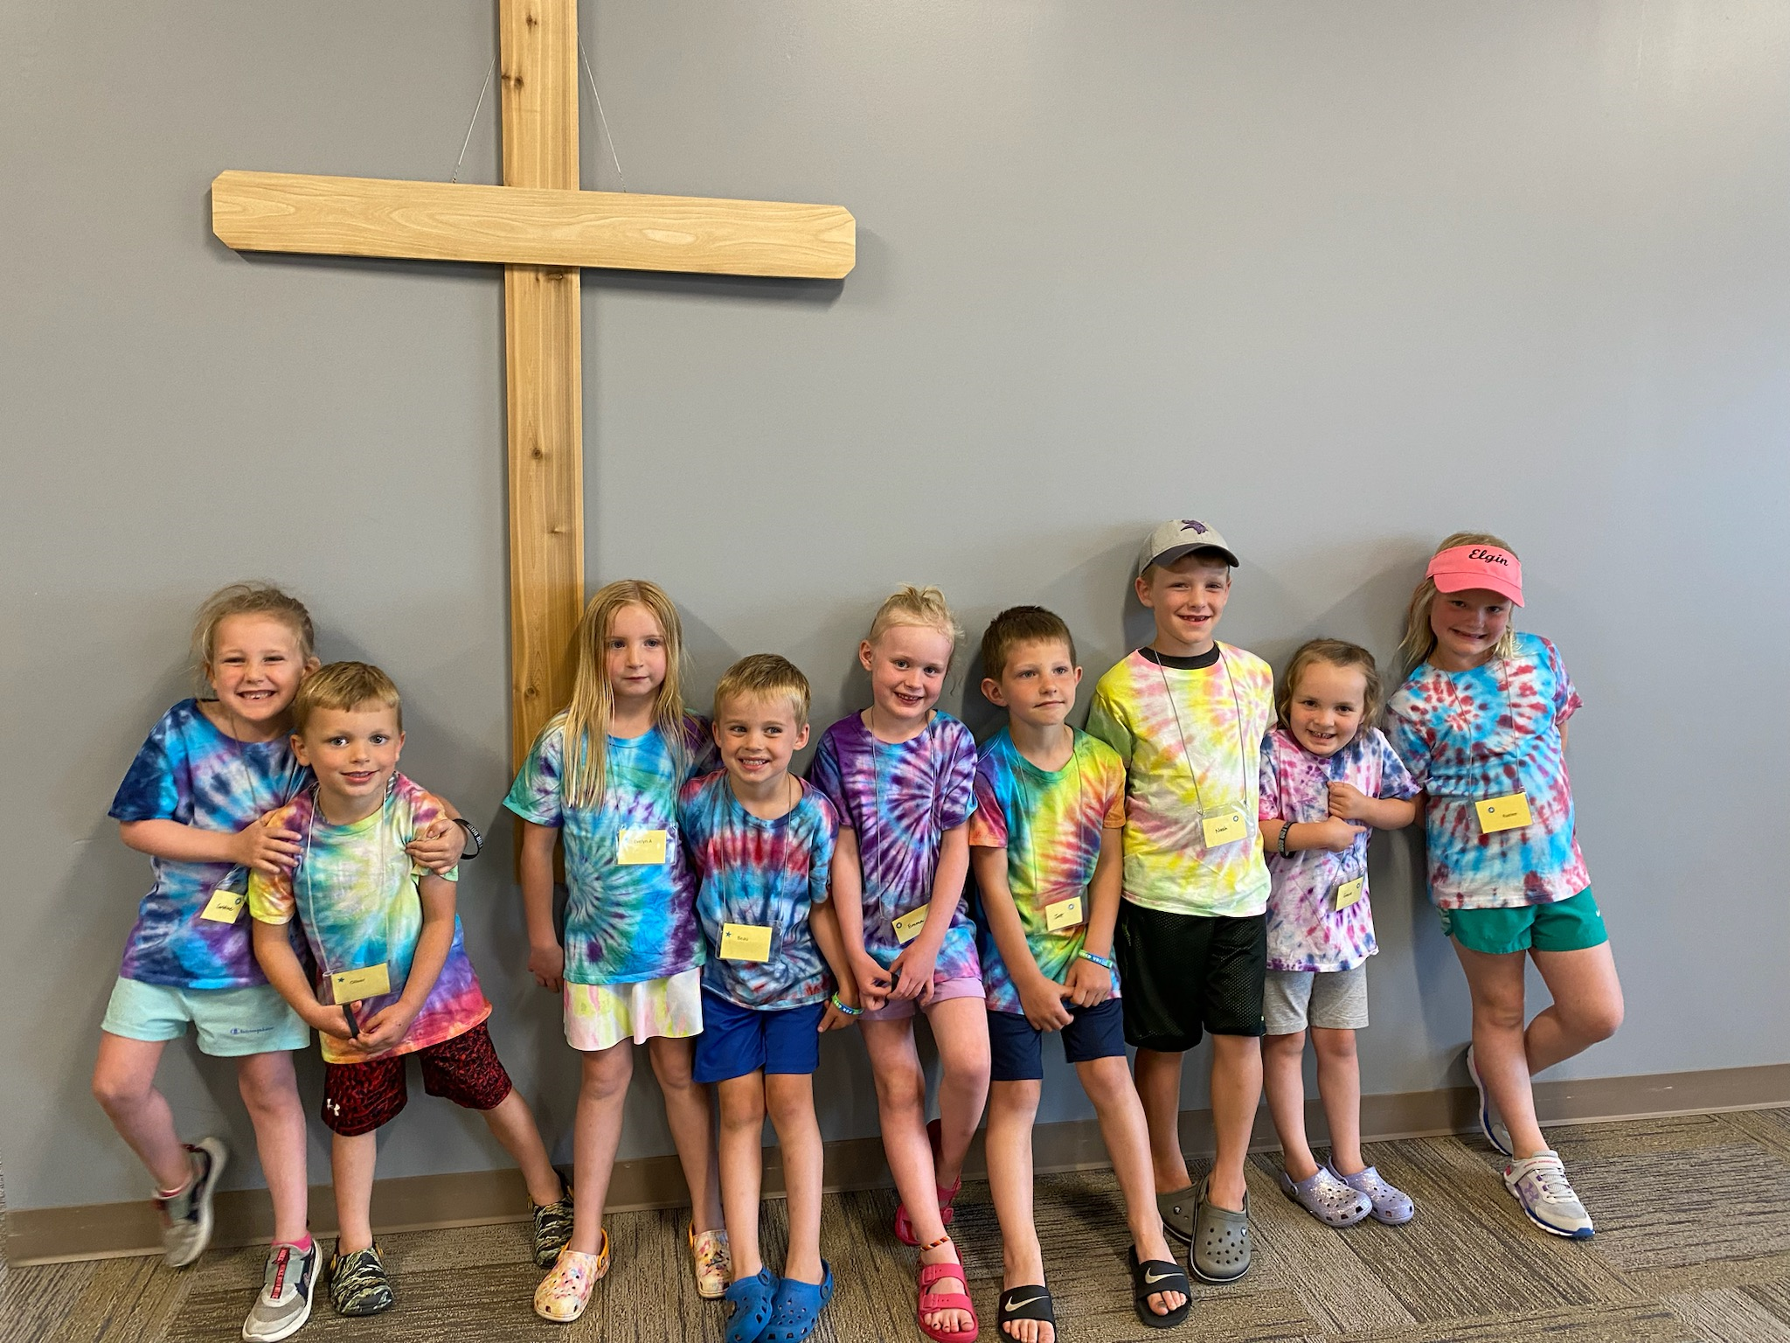

First Communion Training
March 17 at 2 pm (Sun)
March 18 at 3:30 pm (Mon)

